DIS-US-Shaman’s Ceremonial objects

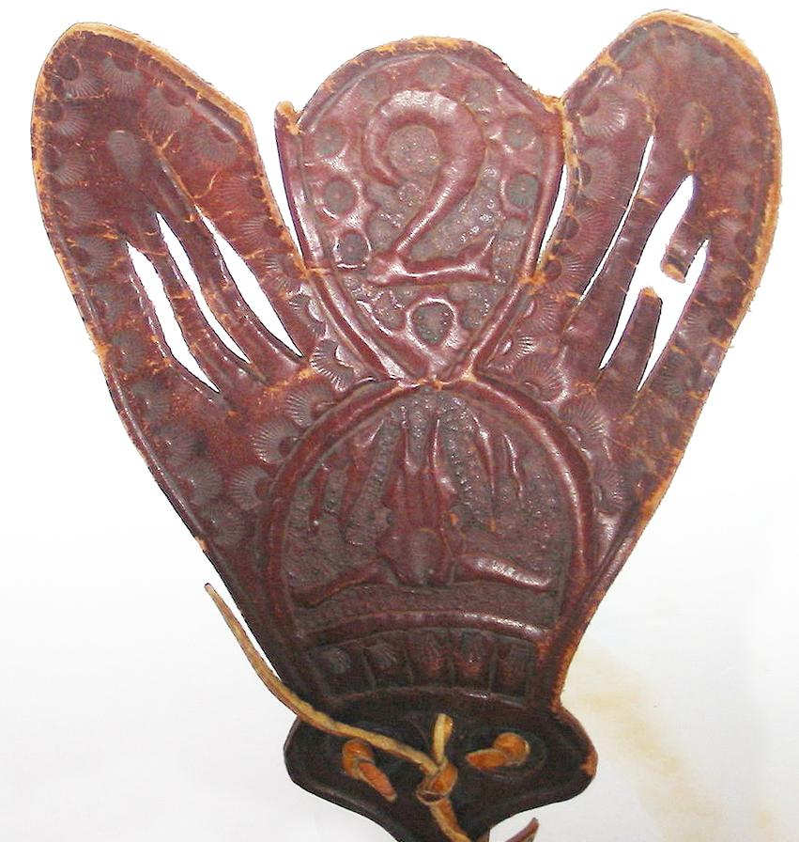 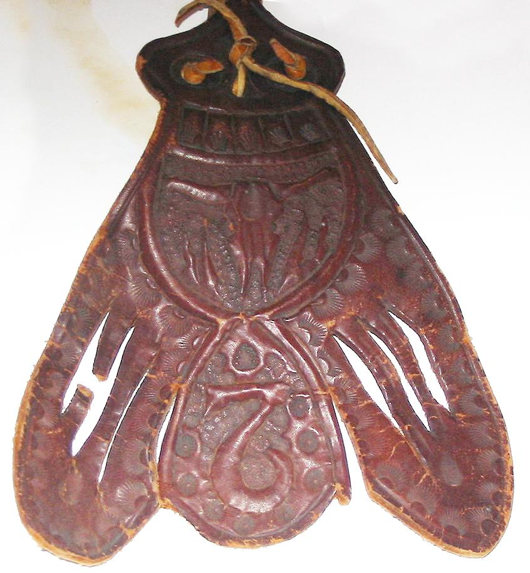

Buffalo Calling Wand in worked brain-tanned leather. The designs show a white buffalo skull, that was the spirit called by the shaman to invoke the finding of herds by the hunters. The upside-down “2” is enigmatic and may be a spirit helper.

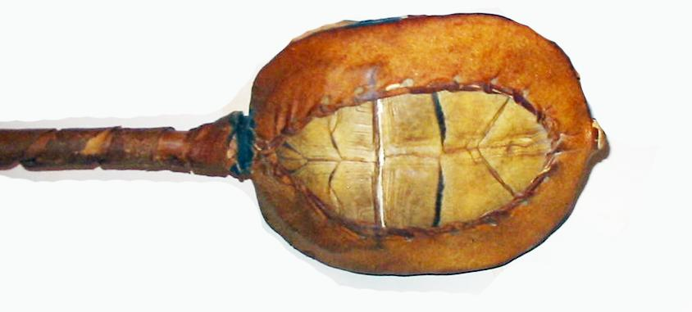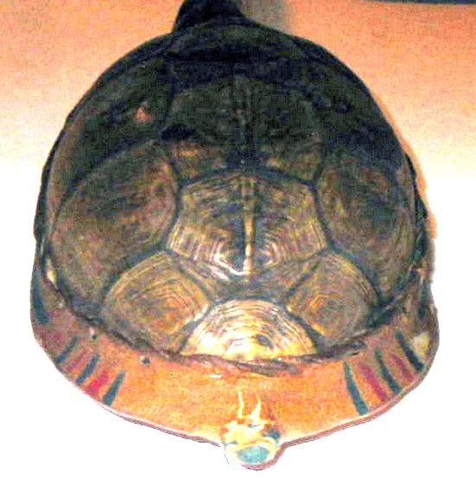

Lakota Sioux shaman’s turtle shell rattle.

Value $2,000

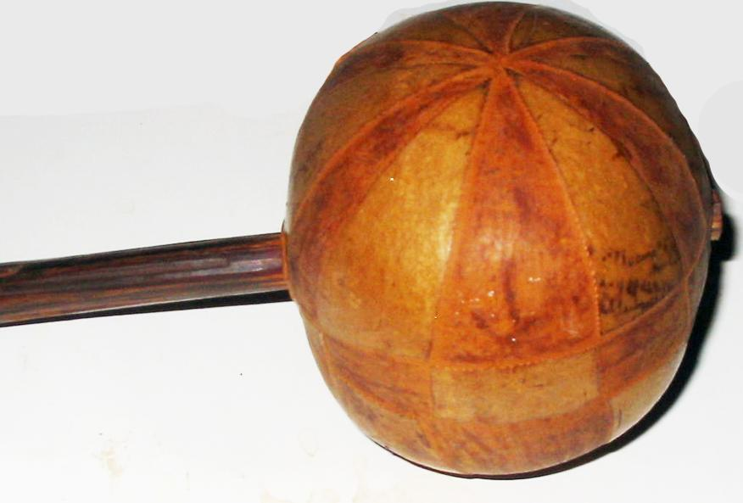

Shaman's Gourd shape rattle late 18th to early 19th century. Dates from 1790's to 1840's .  
Two parts carved wood in a melon-form rattle. Rare and in the condition it's in could easily can be placed in a museum's collection. Gourd shape rattle shows the tripartite universe: upper world, middle world and underworld and the shaman’s way to ascend to the upper world or descend into the lower world.

Value $4,000

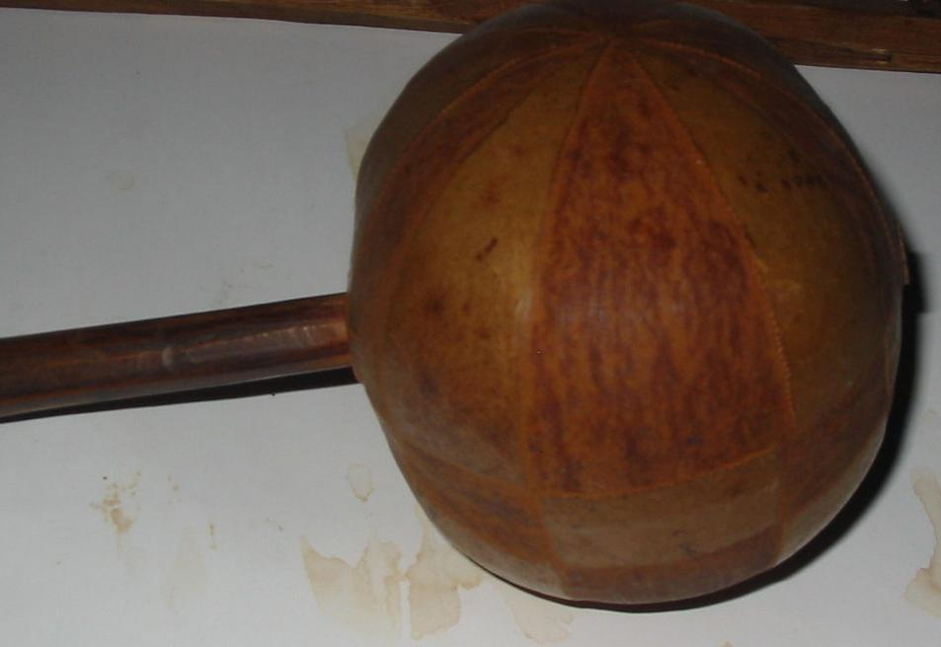

|  |  |
| --- | --- |
| ORDER DATEApr 10, 2016 | ORDER TOTAL  US $127.50  + US $13.45  shipping  **Order TWO RATTERS ONE TURTLE SHELL OTHER GOURD ALSO LEATHER FLY SWATTER** [Leave feedback - ORDER DATE Apr 10, 2016](http://feedback.ebay.com/ws/eBayISAPI.dll?LeaveFeedbackShow&useridto=samgreen222&transactID=0&item=131767762100&_trksid=p2057872.m2749.l2665)[View order details](http://payments.ebay.com/ws/eBayISAPI.dll?ViewPaymentStatus&transId=0&itemid=131767762100&_trksid=p2057872.m2749.l2673) - ORDER DATE Apr 10, 2016  [More actions - ORDER DATE Apr 10, 2016](http://www.ebay.com/myb/PurchaseHistory) |

1 item sold by [samgreen222](http://www.ebay.com/usr/samgreen222?_trksid=p2057872.m2749.l2754)

|  |  |  |
| --- | --- | --- |
| [TWO RATTERS ONE TURTLE SHELL OTHER GOURD ALSO LEATHER FLY SWATTER](http://www.ebay.com/itm/131767762100?_trksid=p2057872.m2749.l2649&ssPageName=STRK%3AMEBIDX%3AIT)  ( 131767762100 )  Delivered on Wed, Apr 13  Tracking number: [**Tracking number**9405509699939852002613](javascript:;)  [Add note](javascript:;) | ITEM PRICE:  US $127.50 |  |

|  |
| --- |
| ORDER DATEApr 10, 2016 |